**Lab 7**

**Exercise 1**

ACME Ltd. has hired you as a developer to develop software to solve their weekly production problem. They have 4 machines. For each machine you must enter the machine code (integer) which should be stored in an array.

Each machine can be operational every day but sometimes, due to malfunction, there is not 100% up time, so you must ask how many days each machine was operational. For each day you must enter the number of widgets produced. If the machine produces less than 100 widgets per day the unit cost of each widget is €0.50, however if the machine produces between 100 and 400 units inclusively per day, the unit cost is €0.40 and if the machine produces more than 400 units per day the unit cost is €0.30.

For each machine print the daily number of widgets produced and their total cost.

You must calculate and print each machine’s weekly production total and the total cost for that machine.

Calculate and print the overall total number of widgets and overall cost of widgets for the company.

The management team wish to know how many machines produce over 1000 units per week, calculate and print this information.

**Sample Output**

Enter machine 1's code:

1001

How many days was machine 1001 operational?

3

Machine: 1001 please enter your production for day 1

50

Machine 1001 for day 1 produced 50 units at a cost of €25.0

Machine: 1001 please enter your production for day 2

200

Machine 1001 for day 2 produced 200 units at a cost of €80.0

Machine: 1001 please enter your production for day 3

600

Machine 1001 for day 3 produced 600 units at a cost of €180.0

Machine 1001 Your weekly production for this week is 850 at a cost of €285.0

Enter machine 2's code:

1002

How many days was machine 1002 operational?

1

Machine: 1002 please enter your production for day 1

700

Machine 1002 for day 1 produced 700 units at a cost of €210.0

Machine 1002 Your weekly production for this week is 700 at a cost of €210.0

Enter machine 3's code:

1003

How many days was machine 1003 operational?

2

Machine: 1003 please enter your production for day 1

800

Machine 1003 for day 1 produced 800 units at a cost of €240.0

Machine: 1003 please enter your production for day 2

900

Machine 1003 for day 2 produced 900 units at a cost of €270.0

Machine 1003 Your weekly production for this week is 1700 at a cost of €510.0

Enter machine 4's code:

1004

How many days was machine 1004 operational?

1

Machine: 1004 please enter your production for day 1

10

Machine 1004 for day 1 produced 10 units at a cost of €5.0

Machine 1004 Your weekly production for this week is 10 at a cost of €5.0

The weekly cost for this week is €1010.0

The weekly production for this week is 3260

The number of machines who produced over 1000 is 1

Thank you

**Exercise 2**

Write a program that allows the user to enter the last names of five candidates in a local election and the votes received by each candidate. The name and votes and percentages should be stored in arrays. The total number of votes cast should be displayed( Note: use a data type of double for the sum variable – for percentage calculation purposes)

The program should then output each candidate’s name, the votes received by that candidate and the percentage of the total votes received by the candidate. Your program should also output the winner of the election.

**Sample Output**

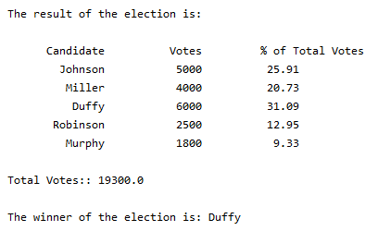

**Exercise 3**

You are required to design and code a program to analyse the performance of the salesmen of a company.

For each salesman, their surname and value of their sales (in euro) are entered

through the keyboard, these should be stored in arrays.

When all salesmen have been entered, the program is required to report the following pieces of information:

* The surname of each employee along with their sales
* The total sales earned by all the salesmen
* The salesman who had the least sales, output the name and sales value
* The salesman who had the most sales, output the name and sales value

The number of salesmen is not known in advance, and the user should enter this number at the start of the program.

**Sample Output**

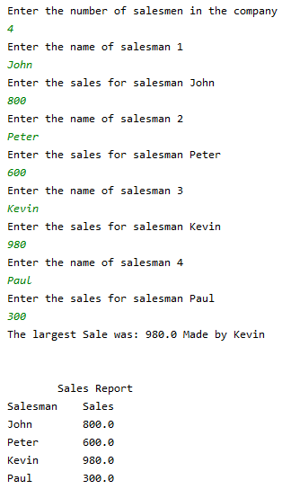

**Exercise 4**

You have been asked to write a software program that allows employers process tax payments due for their employees.

There are 5 employees in the company.

For each employee the system needs to store the employee’s PPS number, e.g. **8765432AA** , the PPS should be entered from the console and should be stored in an array.(Use next() in the java program)

The new tax system introduced in the budget means that there are several new tax bands and allowances for different types of employees.

The system must accept the gross pay earned by the employee and calculate their net pay according to the business rules below.

Type **A**: An employee earning less than or equal to €10000 pays no tax

Type **B**: An employee earning more than €10000 and less than or equal to €2000 pays 30% tax on all income over €10000

Type **C**: An employee earning more than €20000 and less than or equal to €50000 pays 35% tax on all income over €10000

Type **D**: An employee earning more than €50000 is granted a tax-free allowance of €15000 and pays 40% tax on everything over that amount.

The net pay for each employee should be stored in an array.

Display the PPs number, gross pay, tax paid and net pay for each employee.

Each employee’s PPS and net pay details should be displayed at the end of the run.

The amount of tax paid in each type ,i.e., B,C,D, should also be calculated and displayed.

The employers wish to know the number of employees in each employee type (i.e. **A,B,C,D**) so that information should be calculated and output at the end of the program

**Sample Output**

Enter employee pps number:

6765456F

Enter employee gross pay

10000

6765456F has gross pay of €10000.0

Paid tax of €0.0 and has net pay of: €10000.0

Enter employee pps number:

8799776F

Enter employee gross pay

15000

8799776F has gross pay of €15000.0

Paid tax of €1500.0 and has net pay of: €13500.0

Enter employee pps number:

3455776G

Enter employee gross pay

20000

3455776G has gross pay of €20000.0

Paid tax of €3000.0 and has net pay of: €17000.0

Enter employee pps number:

9899765J

Enter employee gross pay

50000

9899765J has gross pay of €50000.0

Paid tax of €14000.0 and has net pay of: €36000.0

Enter employee pps number:

3456783W

Enter employee gross pay

55000

3456783W has gross pay of €55000.0

Paid tax of €16000.0 and has net pay of: €39000.0

PPS Number Net Pay

6765456F 10000.0

8799776F 13500.0

3455776G 17000.0

9899765J 36000.0

3456783W 39000.0

Tax paid in each bracket

Total Tax Type B: 4500.0

Total Tax Type C: 14000.0

Total Tax Type D: 16000.0

Total numbers in each bracket

Number in Type A: 1

Number in Type B: 2

Number in Type C: 1

Number in Type D: 1